## TW-9: Understanding the working of Ipv6 in Low power lossy network

#### Steps to open the cooja simulator

Vmware->Open Virtual machine _>E drive-> Ubuntu_Cooja->Ubuntu 1804_64 bit->Open->Resume

Username-> lab2 Password->git12345

1. Goto root directory
2. cd contiki-ng
3. cd tools
4. cd cooja
5. ant run

#### Steps to create motes and configure them as server and client

1. Goto File -> New Simulation
2. Name the simulation and click on create
3. Click on Motes -> Add motes -> Create a new mote type -> Sky mote
4. Click on Browse and select ipv6-hooks.c (/contiki-ng/examples/libs/ipv6-hooks)
5. Click on open and then on compile and then on create
6. Enter the number of motes as 4 and click on Add motes
7. Place all motes close to each other such that the coverage is 100% for each of them
8. Right click on mote 1 and then click More tools for Sky 1 and then on Serial Socket (SERVER). Mote 1 has been configured as Server.
9. Similarly, configure motes 2, 3 and 4 as clients.
10. Copy the server’s listening port number and paste it as the port number for all clients.
11. Start the server and connect the client to the server.
12. Run the simulation by clicking on Simulation -> Run Simulation

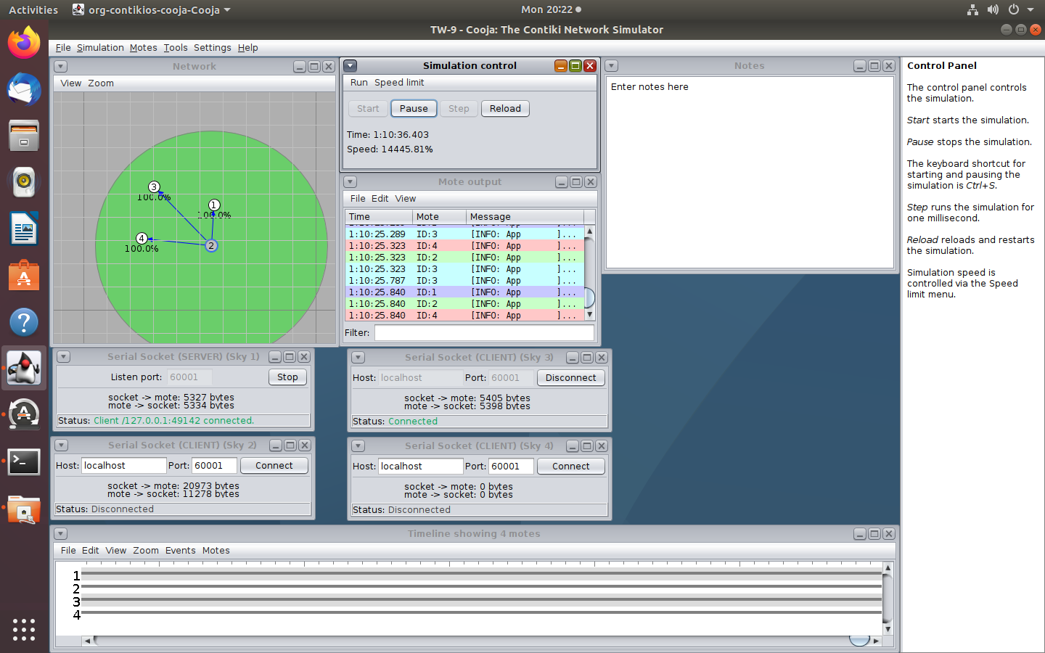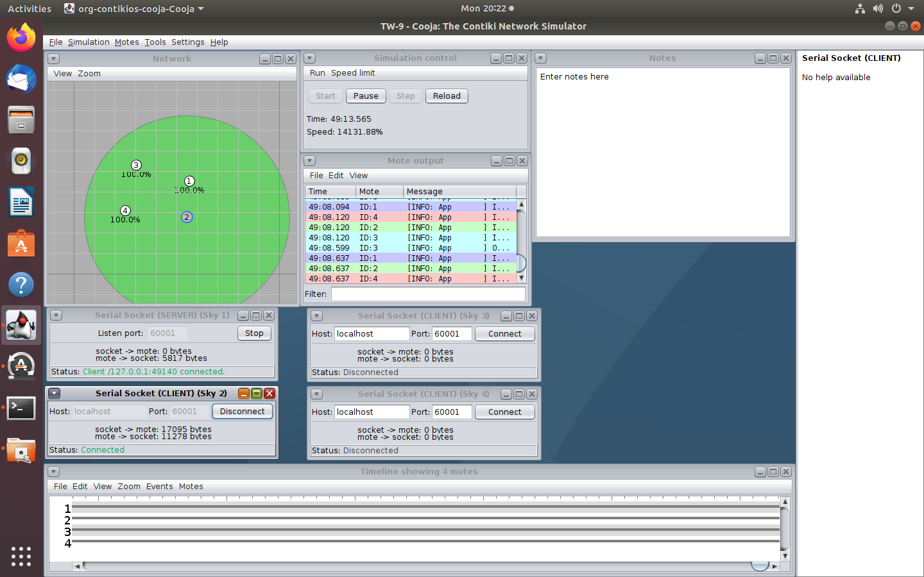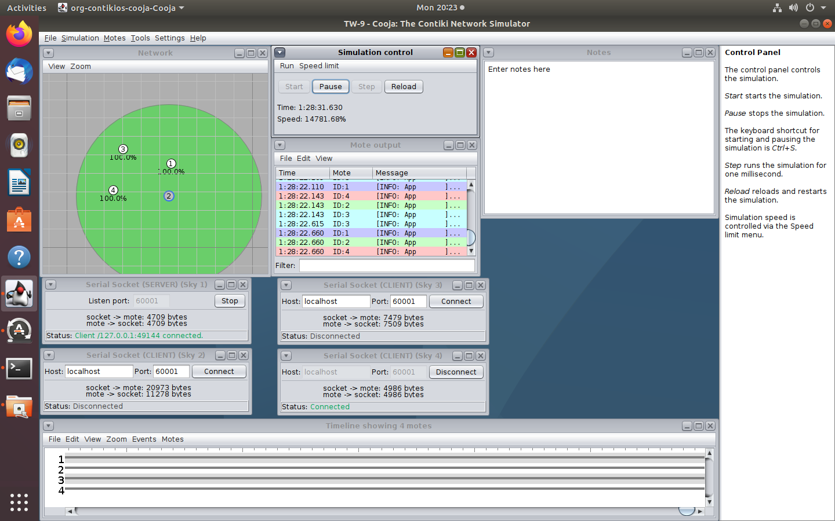

## TW-10: Understanding the working of IoT routing using RPL protocol

Follow the exact same steps to create 2 motes (client and server).

1. Click on Browse and select rpl-udp(/contiki-ng/examples/libs/rpl-udp)
2. Create udp-server.c and add 1 mote by clicking Motes -> Add new Mote -> Browse
3. Create udp-client.c and add 1 mote
4. Place both the motes close to each other
5. Configure 1 as server and 2 as client
6. Copy the server’s port number to the client.
7. Start the server and connect the client.
8. Run the simulation.

